# Drop in user engagement exercise

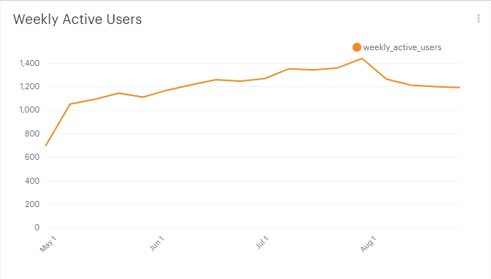

Drop starts in the week of Aug-4 2013.

## Daily login pattern

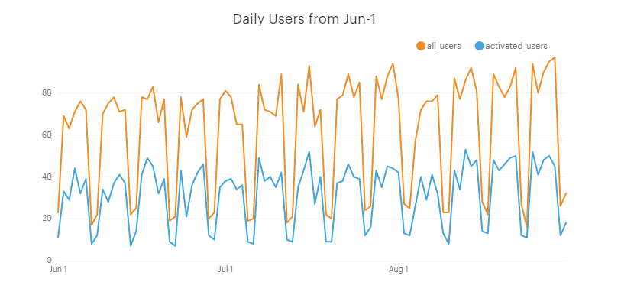

The pattern of daily users shows a drop for the entire week of Aug-4. This could be accountable to users being on holidays as Yammer is essentially a corporate tool and would therefore be expected to have lower usage while people are away from work. September data would confirm this.

## Logins by user age

User_id increases linearly as each new user is added; hence can look at age of users by user_id < x as a proxy for user age. Total of 19.065 users, can divide into batches of users and look at the progression of engagement by batch.

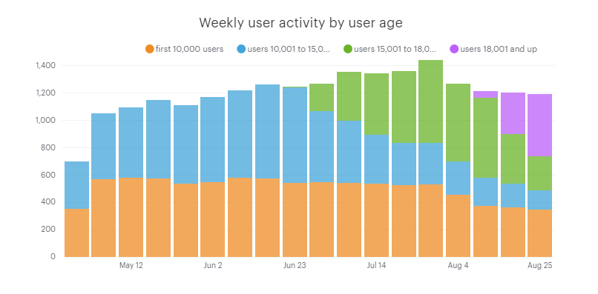

This chart shows that the second batch (user_id 10,001-15,000) and third batch (user_id 15,001 to 18,000) in particular suffered a decline after a certain period of engagement and new users accounted for a significant part of the total activity, disproportionate to their batch size (just over 1,000 users vs. 10,000 users in the first batch). Hence Yammer’s issue seems to be maintaining customer loyalty after the initial first few weeks of activity. Notably the first batch of 10,000 users has been relatively consistent in activity, although for this group as well there is a notable drop from Aug-4, as with the other two groups.

|  |  |  |  |  |  |
| --- | --- | --- | --- | --- | --- |
|  | date_trunc | first 10,000 users | users 10,001 to 15,000 | users 15,001 to 18,000 | users 18,001 and up |
| 1 | 2014-04-28 00:00:00 | 353 | 348 | 0 | 0 |
| 2 | 2014-05-05 00:00:00 | 567 | 487 | 0 | 0 |
| 3 | 2014-05-12 00:00:00 | 579 | 515 | 0 | 0 |
| 4 | 2014-05-19 00:00:00 | 575 | 572 | 0 | 0 |
| 5 | 2014-05-26 00:00:00 | 534 | 579 | 0 | 0 |
| 6 | 2014-06-02 00:00:00 | 549 | 624 | 0 | 0 |
| 7 | 2014-06-09 00:00:00 | 581 | 638 | 0 | 0 |
| 8 | 2014-06-16 00:00:00 | 573 | 689 | 0 | 0 |
| 9 | 2014-06-23 00:00:00 | 543 | 699 | 7 | 0 |
| 10 | 2014-06-30 00:00:00 | 547 | 519 | 205 | 0 |
| 11 | 2014-07-07 00:00:00 | 544 | 453 | 358 | 0 |
| 12 | 2014-07-14 00:00:00 | 534 | 359 | 452 | 0 |
| 13 | 2014-07-21 00:00:00 | 526 | 307 | 530 | 0 |
| 14 | 2014-07-28 00:00:00 | 529 | 306 | 607 | 0 |
| 15 | 2014-08-04 00:00:00 | 456 | 245 | 565 | 0 |
| 16 | 2014-08-11 00:00:00 | 376 | 205 | 585 | 49 |
| 17 | 2014-08-18 00:00:00 | 361 | 176 | 364 | 302 |
| 18 | 2014-08-25 00:00:00 | 348 | 142 | 245 | 459 |
|  |  |  |  |  |  |

Percentage user change by batch in weeks 15-19:

|  |  |  |  |  |  |
| --- | --- | --- | --- | --- | --- |
|  | date_trunc | first 10,000 users | users 10,001 to 15,000 | users 15,001 to 18,000 | users 18,001 and up |
| 15 | 8/4/2014 0:00 | -13.8% | -19.9% | -6.9% |  |
| 16 | 8/11/2014 0:00 | -17.5% | -16.3% | 3.5% |  |
| 17 | 8/18/2014 0:00 | -4.0% | -14.1% | -37.8% | 516.3% |
| 18 | 8/25/2014 0:00 | -3.6% | -19.3% | -32.7% | 52.0% |
|  |  |  |  |  |  |

Absolute change in users by batch in weeks 15-19:

|  |  |  |  |  |  |
| --- | --- | --- | --- | --- | --- |
|  | date_trunc | first 10,000 users | users 10,001 to 15,000 | users 15,001 to 18,000 | users 18,001 and up |
| 15 | 8/4/2014 0:00 | -73 | -61 | -42 | 0 |
| 16 | 8/11/2014 0:00 | -80 | -40 | 20 | 49 |
| 17 | 8/18/2014 0:00 | -15 | -29 | -221 | 253 |
| 18 | 8/25/2014 0:00 | -13 | -34 | -119 | 157 |
|  |  |  |  |  |  |

At this point there is still no root cause for the drop occurring from week 15; in order to discover possible causes we can look at logins by device or by location.

**Code**

SELECT DATE_TRUNC('week', e.occurred_at),

COUNT(DISTINCT CASE WHEN e.user_id <= 10000 THEN e.user_id ELSE NULL END) AS "first 10,000 users",

COUNT(DISTINCT CASE WHEN e.user_id <= 15000 AND e.user_id > 10000 THEN e.user_id ELSE NULL END) AS "users 10,001 to 15,000",

COUNT(DISTINCT CASE WHEN e.user_id < 18000 AND e.user_id > 15000 THEN e.user_id ELSE NULL END) AS "users 15,001 to 18,000",

COUNT(DISTINCT CASE WHEN e.user_id > 18000 THEN e.user_id ELSE NULL END) AS "users 18,001 and up"

FROM tutorial.yammer_events e

WHERE e.event_type = 'engagement' AND e.event_name = 'login'

GROUP BY 1

ORDER BY 1

## Logins by device

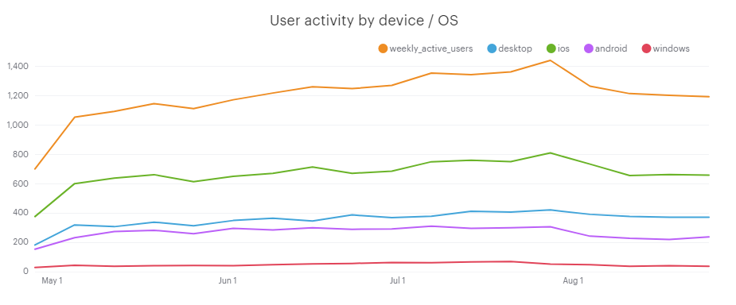

Activity by device shows the decline in total users coincides with a notable drop in iOS and Android users. Desktop and Mac users show a much smaller decline. Hence a possible reason for the drop is a feature change in iOS and Android that users did not like.

|  |  |  |  |  |  |  |  |
| --- | --- | --- | --- | --- | --- | --- | --- |
|  | date_trunc | weekly_  active_users | desktop | mac | ios | android | windows |
| 1 | 4/28/2014 0:00 | 701 | 182 | 216 | 179 | 153 | 29 |
| 2 | 5/5/2014 0:00 | 1054 | 319 | 367 | 292 | 232 | 44 |
| 3 | 5/12/2014 0:00 | 1094 | 307 | 383 | 307 | 274 | 37 |
| 4 | 5/19/2014 0:00 | 1147 | 338 | 391 | 324 | 282 | 40 |
| 5 | 5/26/2014 0:00 | 1113 | 313 | 360 | 308 | 259 | 42 |
| 6 | 6/2/2014 0:00 | 1173 | 349 | 410 | 306 | 296 | 40 |
| 7 | 6/9/2014 0:00 | 1219 | 365 | 392 | 338 | 284 | 47 |
| 8 | 6/16/2014 0:00 | 1262 | 346 | 419 | 351 | 299 | 53 |
| 9 | 6/23/2014 0:00 | 1249 | 387 | 408 | 324 | 289 | 56 |
| 10 | 6/30/2014 0:00 | 1271 | 368 | 393 | 364 | 292 | 63 |
| 11 | 7/7/2014 0:00 | 1355 | 378 | 442 | 380 | 310 | 61 |
| 12 | 7/14/2014 0:00 | 1345 | 412 | 453 | 368 | 296 | 67 |
| 13 | 7/21/2014 0:00 | 1363 | 406 | 451 | 365 | 299 | 69 |
| 14 | 7/28/2014 0:00 | 1442 | 421 | 480 | 395 | 306 | 51 |
| 15 | 8/4/2014 0:00 | 1266 | 391 | 471 | 317 | 242 | 48 |
| 16 | 8/11/2014 0:00 | 1215 | 377 | 438 | 281 | 228 | 36 |
| 17 | 8/18/2014 0:00 | 1203 | 372 | 462 | 264 | 220 | 41 |
| 18 | 8/25/2014 0:00 | 1194 | 372 | 442 | 271 | 237 | 37 |

Percent change

|  |  |  |  |  |  |  |  |
| --- | --- | --- | --- | --- | --- | --- | --- |
|  | date_trunc | weekly_  active_users | desktop | mac | ios | android | windows |
| 15 | 8/4/2014 0:00 | -12.2% | -7.1% | -1.9% | -19.7% | -20.9% | -5.9% |
| 16 | 8/11/2014 0:00 | -4.0% | -3.6% | -7.0% | -11.4% | -5.8% | -25.0% |
| 17 | 8/18/2014 0:00 | -1.0% | -1.3% | 5.5% | -6.0% | -3.5% | 13.9% |
| 18 | 8/25/2014 0:00 | -0.7% | 0.0% | -4.3% | 2.7% | 7.7% | -9.8% |

**Code**

SELECT DATE_TRUNC('week', e.occurred_at),

COUNT(DISTINCT e.user_id) AS weekly_active_users,

COUNT(DISTINCT CASE WHEN e.device IN ( 'acer inspire desktop', 'acer inspire notebook', 'asus chromebook', 'dell inspiron desktop', 'dell inspiron notebook', 'hp pavillion desktop', 'lenovo thinkpad') THEN e.user_id ELSE NULL END) AS desktop,

COUNT(DISTINCT CASE WHEN e.device IN ('iphone 4s', 'iphone 5', 'iphone 5s', 'ipad air', 'ipad mini', 'macbook air', 'macbook pro', 'mac mini') THEN e.user_id ELSE NULL END) AS ios,

COUNT(DISTINCT CASE WHEN e.device IN ('samsung galaxy tablet', 'samsung galaxy note', 'samsung galaxy s4', 'nexus 10', 'nexus 5', 'nexus 7', 'htc one') THEN e.user_id ELSE NULL END) AS android,

COUNT(DISTINCT CASE WHEN e.device IN ('nokia lumia 635', 'windows surface') THEN e.user_id ELSE NULL END) AS windows

FROM tutorial.yammer_events e

WHERE e.event_type = 'engagement'

AND e.event_name = 'login'

GROUP BY 1

ORDER BY 1

## Logins by Location

|  |  |  |  |  |  |  |  |  |  |
| --- | --- | --- | --- | --- | --- | --- | --- | --- | --- |
|  | date_trunc | weekly_  active_users | usa | uk | germany | japan | brazil | canada | australia |
| 1 | 4/28/2014 0:00 | 701 | 203 | 33 | 42 | 47 | 28 | 24 | 17 |
| 2 | 5/5/2014 0:00 | 1054 | 294 | 49 | 72 | 76 | 36 | 35 | 26 |
| 3 | 5/12/2014 0:00 | 1094 | 296 | 52 | 69 | 80 | 32 | 35 | 28 |
| 4 | 5/19/2014 0:00 | 1147 | 289 | 62 | 74 | 80 | 41 | 36 | 24 |
| 5 | 5/26/2014 0:00 | 1113 | 301 | 59 | 78 | 85 | 39 | 32 | 20 |
| 6 | 6/2/2014 0:00 | 1173 | 318 | 70 | 77 | 87 | 38 | 33 | 27 |
| 7 | 6/9/2014 0:00 | 1219 | 362 | 59 | 75 | 90 | 46 | 39 | 28 |
| 8 | 6/16/2014 0:00 | 1262 | 370 | 56 | 85 | 90 | 45 | 39 | 27 |
| 9 | 6/23/2014 0:00 | 1249 | 357 | 61 | 79 | 86 | 34 | 31 | 25 |
| 10 | 6/30/2014 0:00 | 1271 | 382 | 50 | 72 | 100 | 46 | 34 | 27 |
| 11 | 7/7/2014 0:00 | 1355 | 376 | 58 | 83 | 97 | 45 | 41 | 28 |
| 12 | 7/14/2014 0:00 | 1345 | 392 | 53 | 96 | 89 | 42 | 36 | 25 |
| 13 | 7/21/2014 0:00 | 1363 | 383 | 65 | 97 | 107 | 49 | 40 | 25 |
| 14 | 7/28/2014 0:00 | 1442 | 424 | 68 | 90 | 107 | 54 | 37 | 38 |
| 15 | 8/4/2014 0:00 | 1266 | 368 | 59 | 80 | 99 | 38 | 37 | 31 |
| 16 | 8/11/2014 0:00 | 1215 | 340 | 48 | 84 | 89 | 44 | 24 | 28 |
| 17 | 8/18/2014 0:00 | 1203 | 351 | 57 | 74 | 94 | 41 | 31 | 26 |
| 18 | 8/25/2014 0:00 | 1194 | 340 | 58 | 77 | 84 | 39 | 31 | 25 |

Percentage change

|  |  |  |  |  |  |  |  |  |  |
| --- | --- | --- | --- | --- | --- | --- | --- | --- | --- |
|  | date_trunc | weekly_  active_users | usa | uk | germany | japan | brazil | canada | australia |
| 15 | 8/4/2014 0:00 | -12.2% | -13.2% | -13.2% | -11.1% | -7.5% | -29.6% | 0.0% | -18.4% |
| 16 | 8/11/2014 0:00 | -4.0% | -7.6% | -18.6% | 5.0% | -10.1% | 15.8% | -35.1% | -9.7% |
| 17 | 8/18/2014 0:00 | -1.0% | 3.2% | 18.8% | -11.9% | 5.6% | -6.8% | 29.2% | -7.1% |
| 18 | 8/25/2014 0:00 | -0.7% | -3.1% | 1.8% | 4.1% | -10.6% | -4.9% | 0.0% | -3.8% |

Most of the major countries (USA, UK, Germany, Japan) demonstrate a drop from week 15 consistent with the overall drop in users, meaning that the overall drop is not attributable to a specific location.

**Code**

SELECT DATE_TRUNC('week', e.occurred_at),

COUNT(DISTINCT e.user_id) AS weekly_active_users,

COUNT(DISTINCT CASE WHEN e.location = 'United States' THEN e.user_id ELSE NULL END) AS USA,

COUNT(DISTINCT CASE WHEN e.location = 'United Kingdom' THEN e.user_id ELSE NULL END) AS UK,

COUNT(DISTINCT CASE WHEN e.location = 'Germany' THEN e.user_id ELSE NULL END) AS Germany,

COUNT(DISTINCT CASE WHEN e.location = 'Japan' THEN e.user_id ELSE NULL END) AS Japan,

COUNT(DISTINCT CASE WHEN e.location = 'Brazil' THEN e.user_id ELSE NULL END) AS Brazil,

COUNT(DISTINCT CASE WHEN e.location = 'Canada' THEN e.user_id ELSE NULL END) AS Canada,

COUNT(DISTINCT CASE WHEN e.location = 'Australia' THEN e.user_id ELSE NULL END) AS Australia

FROM tutorial.yammer_events e

WHERE e.event_type = 'engagement'

AND e.event_name = 'login'

GROUP BY 1

ORDER BY 1

## Conclusion

Possible causes of a drop in user engagement starting Aug-4:

* The drop occurs in the most active weeks of the holiday season, and no data is available for September to show if user engagement recovers
* Analysis by user age group (according to when the user signed up) shows that users of all age groups reduced activity in that wee, including the oldest group which had shown a stable level of use in the weeks preceding Aug-4.
* Analysis by device used shows a notable drop in iOS and Android based devices, and a smaller drop in desktop devices. This points to the possibility of a feature change that was disliked especially by users on these devices and this led to the drop.
* Location analysis does not show the drop being attributable to a particular location.

So far the most indicative result is the drop in iOS and Android users. An investigation into software changes preceding the drop would provide further detail to determine if the drop is attributable to a specific feature.